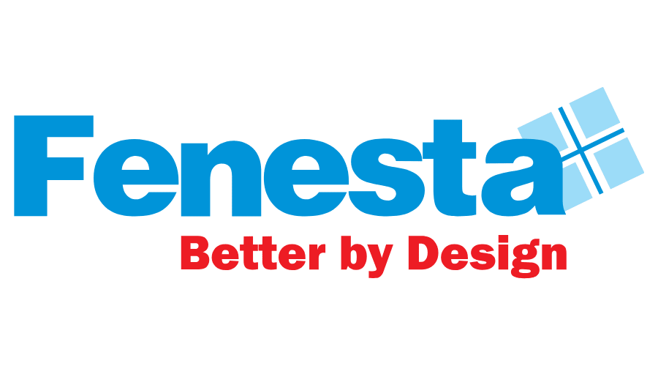
FENESTA EXPANDS ITS RETAIL PRESENCE IN HAMIRPUR, HIMACHAL PRADESH
Himachal Pradesh, 15th April, 2024: Fenesta, India’s largest Windows and Doors Brand which is also the market leader in its segment, reinforced its retail expansion with the opening another new showroom. The exclusive showroom S & B Spaces is located at W, no. 1, Krishna Nagar, Near Pucca Bharo Chowk, Hamirpur, Himachal Pradesh – 177001 and brings the best in class Aluminum windows and Doors, uPVC Windows & Door and Solid Panel Doors.
Speaking on the occasion, Mr. Saket Jain, Business Head, Fenesta said, “Our commitment to customer satisfaction, coupled with our diverse product range, continues to fuel our sustained growth. Each new showroom is a testament to the confidence our customers place in us, representing our ongoing dedication to providing exceptional service. More than physical spaces, our showrooms transform into vibrant hubs where customers can fully immerse themselves in our products, engage with our brand, and make well-informed decisions. The opening of our latest showroom marks a significant stride in our mission to expand our presence nationwide.”

With this launch, Fenesta marks another milestone to ensure an interactive and informative buying experience for our existing and potential customers. Fenesta Showrooms have been successfully contributing to a significant customer reach and positioning as a market leader. With the rapid growth in Aluminum windows and Doors, uPVC Windows & Door, Solid Panel Doors and Facades categories in India, the brand endeavors to further increase its market share and maintain its leadership position in future.

He further added that “Through the steadfast support and belief of our partners and stakeholders, we've reached an incredible milestone. Our journey has been remarkable, and now we're poised for even more growth ahead. This success is a result of our strong marketing, diverse product range, and focused attention on Tier 2 and Tier 3 markets. We've carefully designed every aspect of our approach to engage, educate, and create lasting memories for our valued customers”.

The Fenesta showroom located at W, no. 1, Krishna Nagar, Near Pucca Bharo Chowk, Hamirpur, Himachal Pradesh – 177001, showcases a range of products from windows, doors and various design and color possibilities. With this launch, Fenesta now has presence in more than 350 locations.

Fenesta is the only company in India to control the entire supply chain starting from the making of uPVC that goes into making the profile, to installation of end product, as well as after sales service. The range of products is specially designed in UK and Austria to give consumers a well-engineered but contemporary style.
The products at Fenesta go through stringent tests and quality check at every step to ensure performance in India’s varied and extreme climates. Fenesta products are immensely popular amongst leading builders, architects and interior designers across the country for its noise insulating, rain insulating, dust proof features without compromise on aesthetics.
###
About Fenesta Building System:
Fenesta is India’s largest windows and doors brand and a part of the Rs. 12,080 Cr conglomerate DCM Shriram Ltd. Its installations across more than 4,00,000 homes have already crossed the magical 4 million mark. Empowered with the knowledge of India's extreme conditions, Fenesta has designed uPVC windows and doors that are able to withstand India's extreme climate also. After uPVC, Fenesta took another technological leap when it introduced its ultra-luxury Aluminium Windows and Doors, Solid Panel Doors and now Facades. Headquartered in Gurgaon, Fenesta has more than 300 dealer showrooms and nine Signature Studios supporting its presence in more than 350 cities. With dynamic direct sales force, Fenesta has successfully expanded its reach internationally, penetrating markets in the Maldives, Nepal, and Bhutan. Fenesta offers a complete customized end-to-end solution: survey, design, manufacture, delivery, installation and service to all its customers. The entire process is synchronized with the pace of each project. As a leader in the category, Fenesta takes pride in its ability to serve individual homes and large developers with equal ease.

For further information, please reach out to:
Gurudiksha Kaur | gurudiksha.kaur@adfactorspr.com

Rahil Siddiqui | rahil.siddiqui@adfactorspr.com

